Step1 : Click the following link:

<https://dev.mysql.com/downloads/file/?id=479861>

scroll down and click

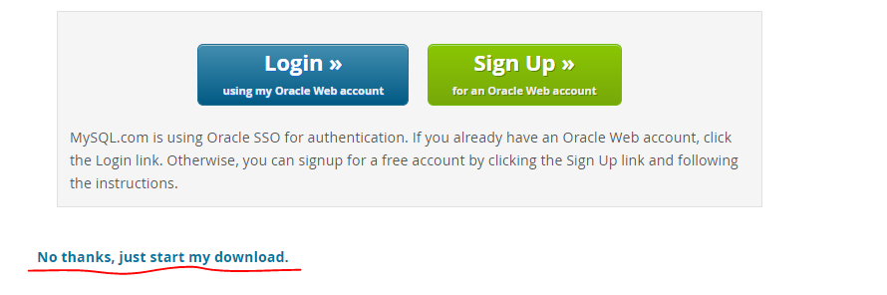

Step 2 : Run the downloaded file, you will get following window

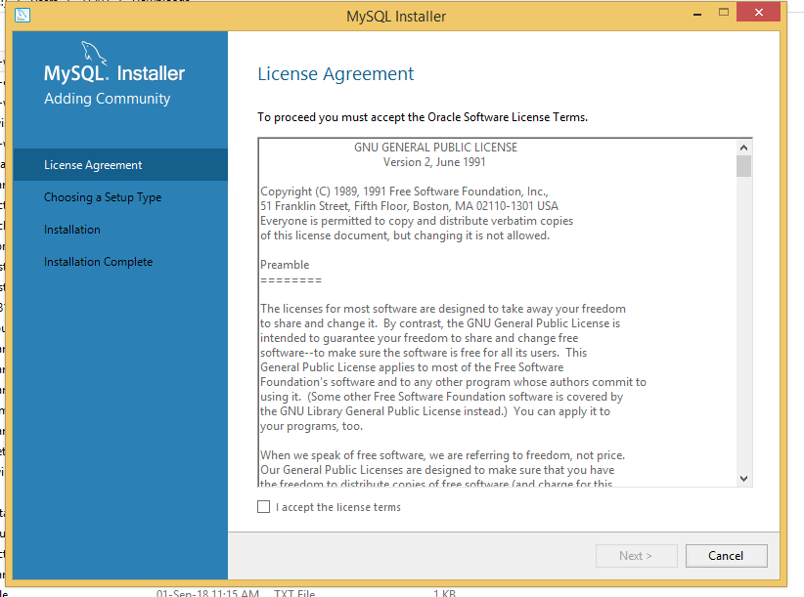

Click I accept and then click next

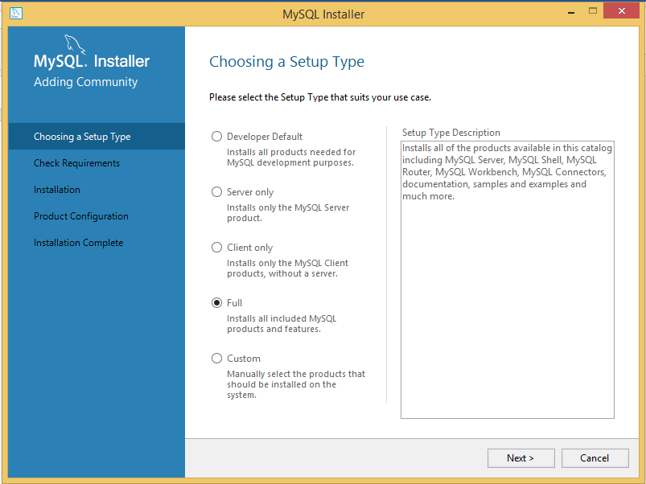

Step 3: select full and then click next

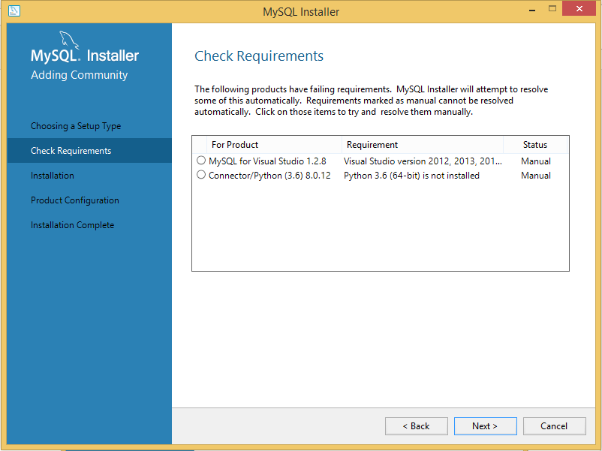

Step 4 : It will show you pre-requisite software (Note: list may vary) . Click Next

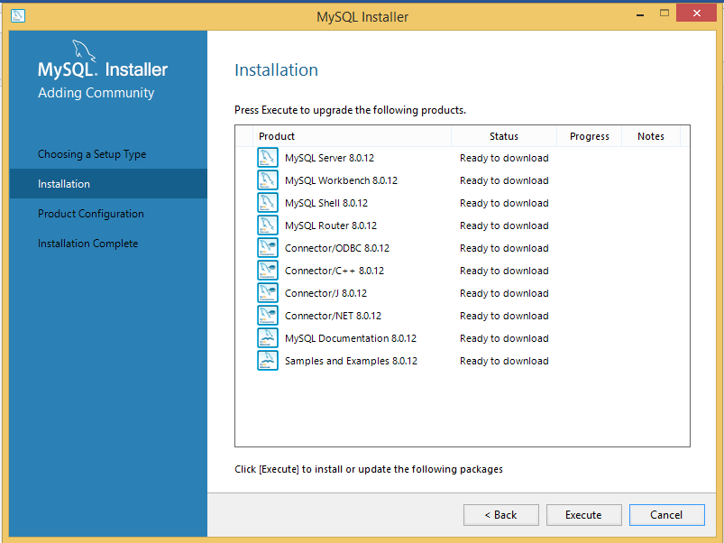

Step 5: It will start downloading all relevant software (make sure internet works well). It might take some time (depends on internet speed)

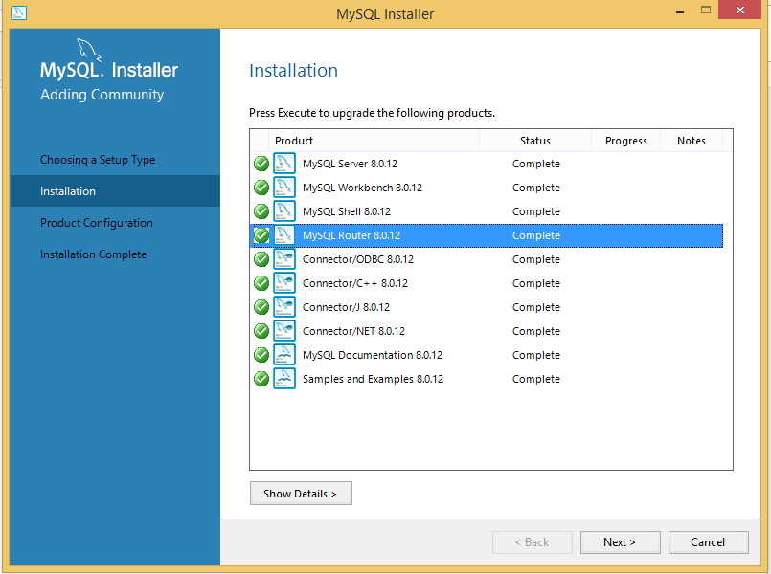

Step 6 : After downloading all software. Click next

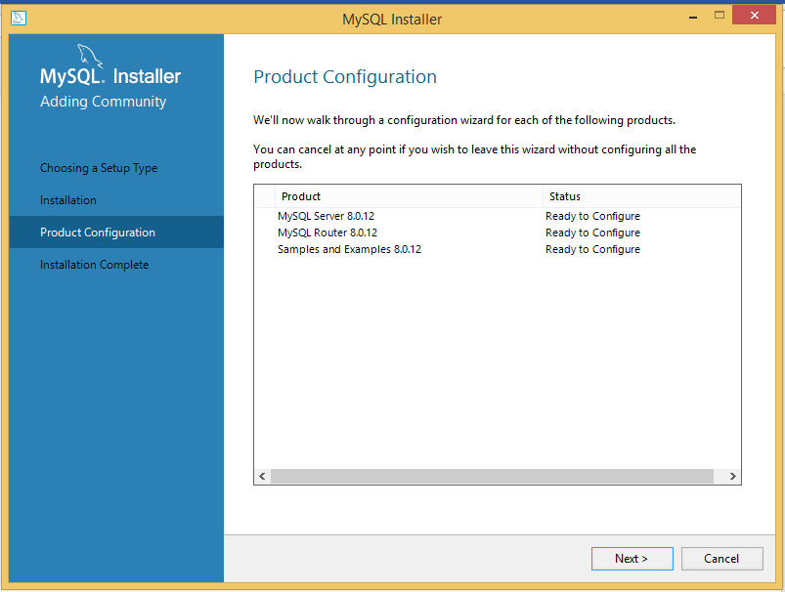

Step 7: click next

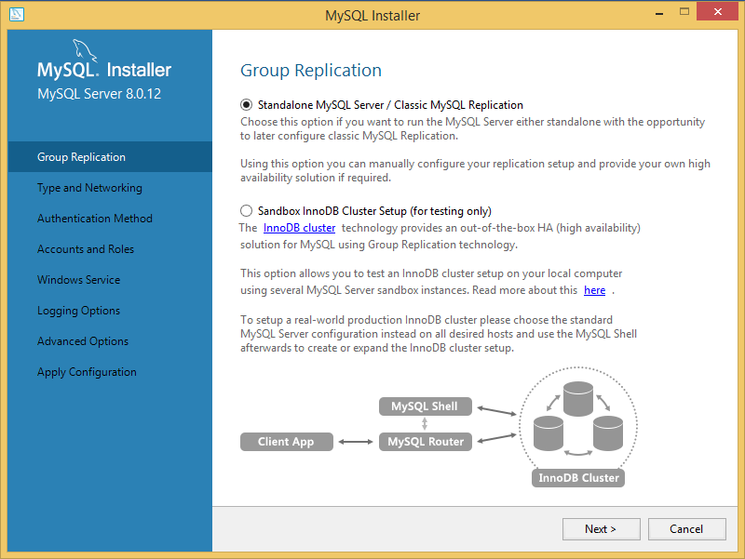

Step 8: click next

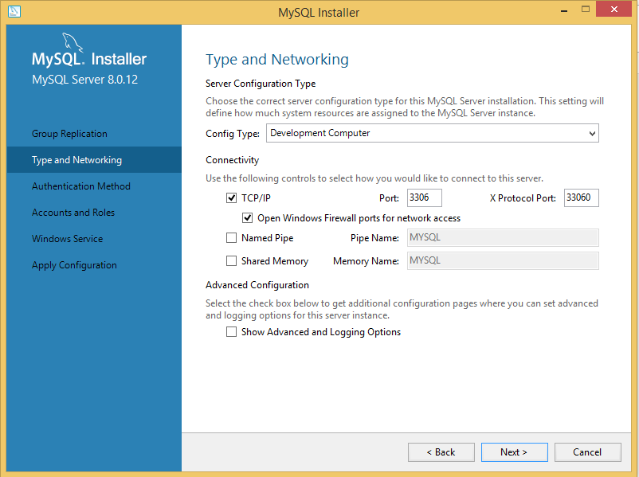

Step 9: click next

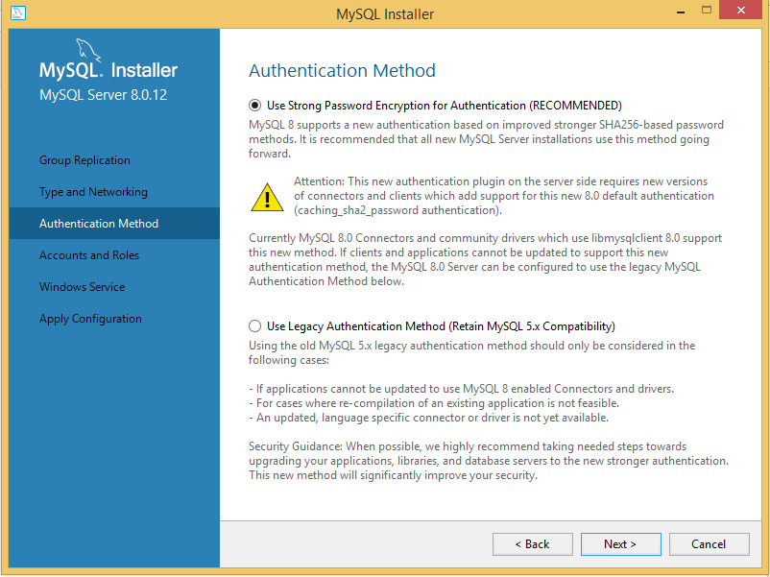

Step10: click next

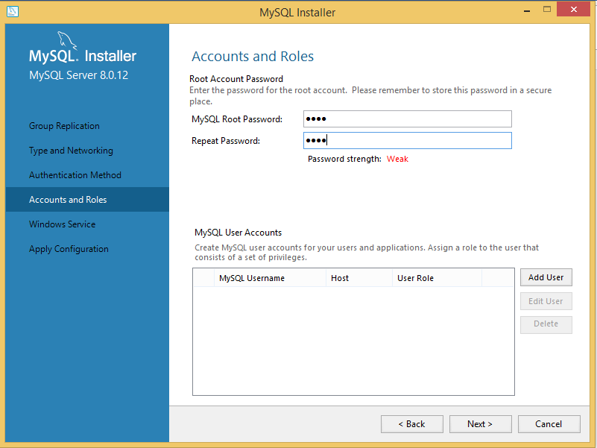

Step 11: Type password as **root** and click next

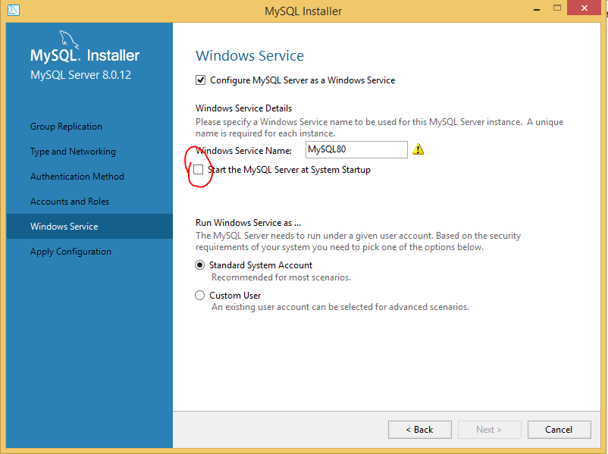

Step 12: uncheck highlighted part and click next

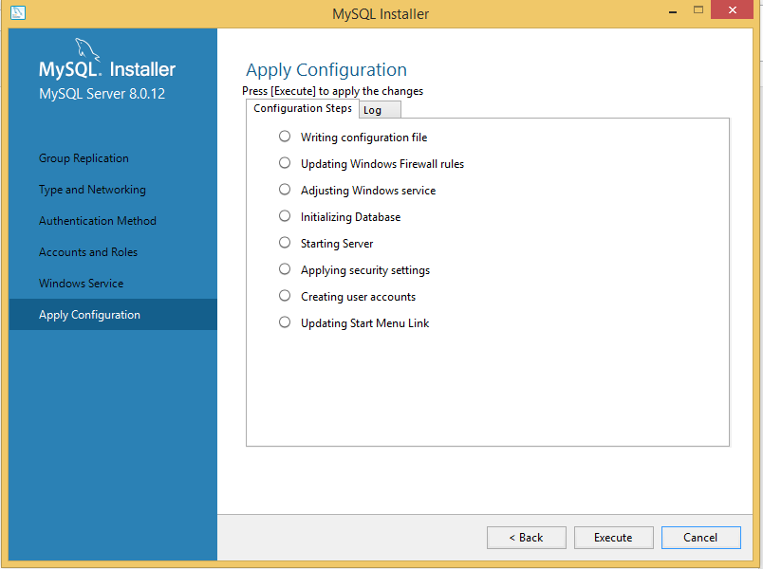

Step 13: click execute

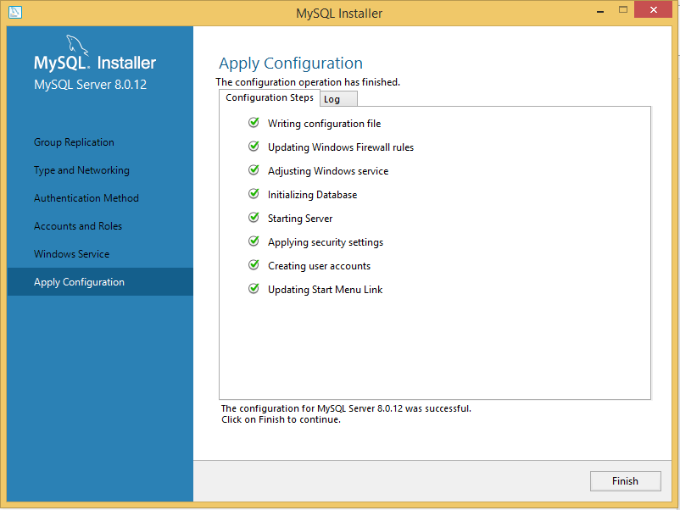

Step 14: If everything is fine click finish. Now it will prompt you to configure mysql router select default options and click next.

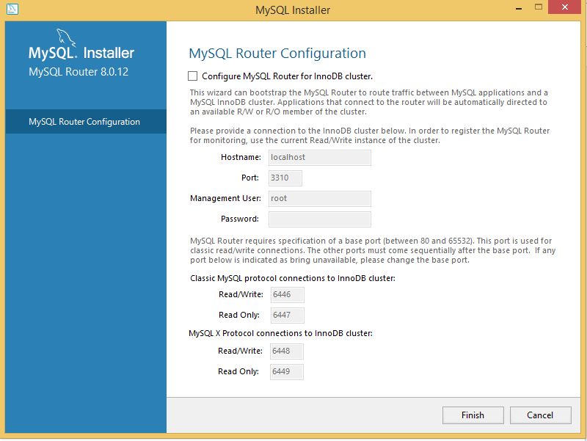

Step 15: Click Finish

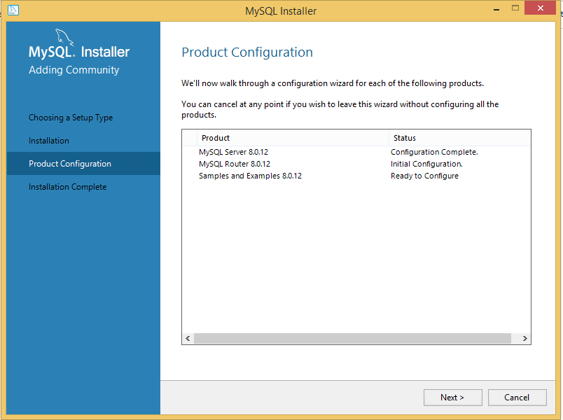

Step 16: Now it will ask you to configure samples simply click next

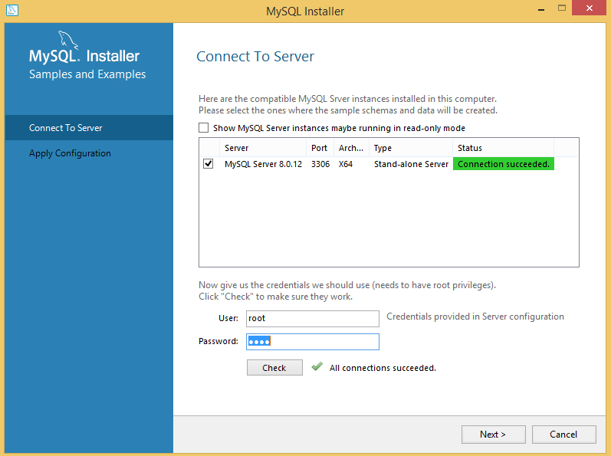

Step 17: enter password as **root** and click next

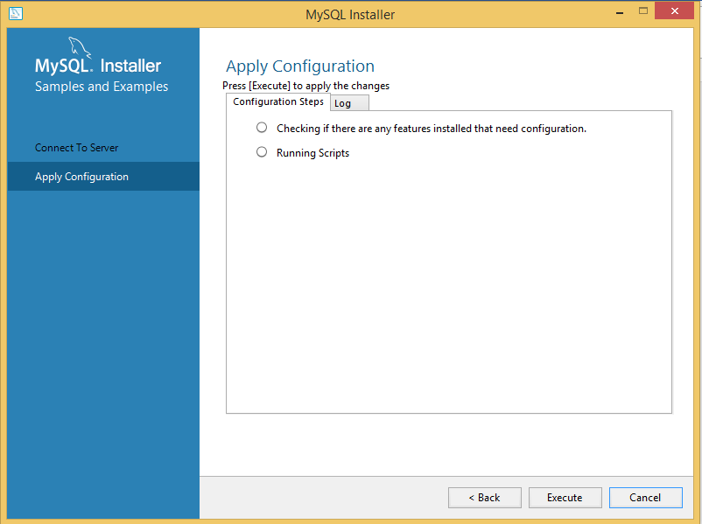

Step 18: click execute

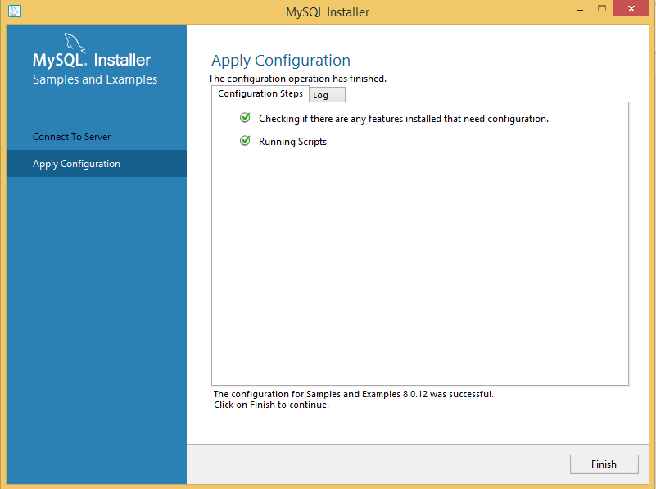

Step 19: Click Finish

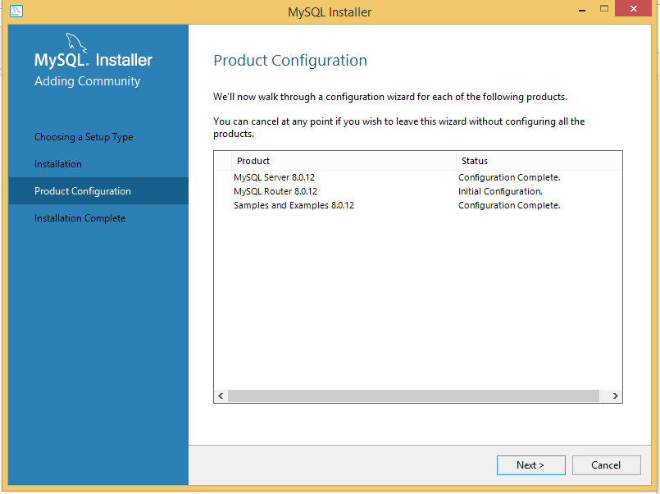

Step 20: click next

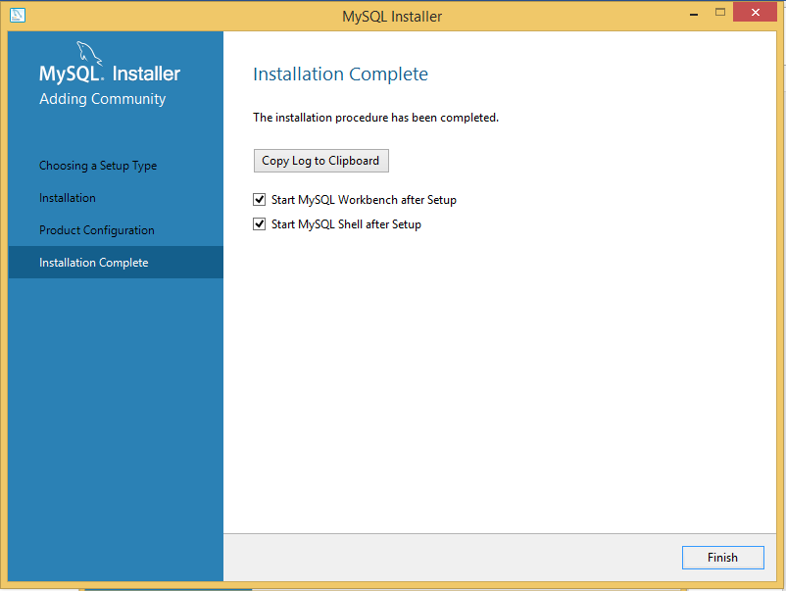

Step 21: click finish